**PROGRAM CODE:**

**//SAVE_DATA**

<?php

$name=$_POST['fullname'];

$number=$_POST['mobileno'];

$email=$_POST['emailid'];

$age=$_POST['age'];

$gender=$_POST['gender'];

$blood_group=$_POST['blood'];

$address=$_POST['address'];

$conn=mysqli_connect("localhost","root","","blood_donation") or die("Connection error");

$sql= "INSERT INTO donor_details(donor_name,donor_number,donor_mail,donor_age,donor_gender,donor_blood,donor_address) values('{$name}','{$number}','{$email}','{$age}','{$gender}','{$blood_group}','{$address}')";

$result=mysqli_query($conn,$sql) or die("query unsuccessful.");

echo "<script>alert('Successfully Requested... ');</script>";

header("Location: http://localhost:7070/blood/index.php");

mysqli_close($conn);

?>

**//INDEX.PHP**

<html>

<head>

<meta charset="utf-8">

<meta name="viewport" content="width=device-width, initial-scale=1, shrink-to-fit=no">

<meta name="description" content="">

<meta name="author" content="">

<link rel="stylesheet" href="https://maxcdn.bootstrapcdn.com/bootstrap/4.5.2/css/bootstrap.min.css">

<script src="https://ajax.googleapis.com/ajax/libs/jquery/3.5.1/jquery.min.js"></script>

<script src="https://cdnjs.cloudflare.com/ajax/libs/popper.js/1.16.0/umd/popper.min.js"></script>

<script src="https://maxcdn.bootstrapcdn.com/bootstrap/4.5.2/js/bootstrap.min.js"></script>

</head>

<body>

<div id="page-container" style="margin-top:50px; position: relative;min-height: 84vh;">

<div class="container">

<div id="content-wrap" style="padding-bottom:50px;">

<div class="row">

<div class="col-lg-6">

<h1 class="mt-4 mb-3">Need Blood</h1>

</div>

</div>

<form name="needblood" action="" method="post">

<div class="row">

<div class="col-lg-4 mb-4">

<div class="font-italic">Blood Group<span style="color:red">*</span></div>

<div><select name="blood" class="form-control" required>

<option value=""selected disabled>Select</option>

<?php

include 'conn.php';

$sql= "select * from blood";

$result=mysqli_query($conn,$sql) or die("query unsuccessful.");

while($row=mysqli_fetch_assoc($result)){

?>

<option value=" <?php echo $row['blood_id'] ?>"> <?php echo $row['blood_group'] ?> </option>

<?php } ?>

</select>

</div>

</div>

<div class="col-lg-4 mb-4">

<div class="font-italic">Reason, why do you need blood?<span style="color:red">*</span></div>

<div><textarea class="form-control" name="address" required></textarea></div></div>

</div>

<div class="row">

<div class="col-lg-1">

<div><input type="submit" name="search" class="btn btn-primary" value="Search" style="cursor:pointer"></div>

</div>

<div class="col-lg-4 mb-4">

Willing To DonateBlood,

<a href="donate_blood.php">

click here to Donate

</a>

</div>

</div><div class="row">

<?php if(isset($_POST['search'])){

$bg=$_POST['blood'];

$sql= "select * from donor_details join blood where donor_details.donor_blood=blood.blood_id AND donor_blood='{$bg}' order by rand() limit 5";

$result=mysqli_query($conn,$sql) or die("query unsuccessful.");

if(mysqli_num_rows($result)>0) {

while($row = mysqli_fetch_assoc($result)) {

?>

<div class="col-lg-4 col-sm-6 portfolio-item" ><br>

<div class="card" style="width:300px">

<img class="card-img-top" src="blood_drop_logo.jpg" alt="Card image" style="width:100%;height:300px">

<div class="card-body">

<h3 class="card-title"><?php echo $row['donor_name']; ?></h3>

<p class="card-text">

<b>Blood Group : </b> <b><?php echo $row['blood_group']; ?></b><br>

<b>Mobile No. : </b> <?php echo $row['donor_number']; ?><br>

<b>Gender : </b><?php echo $row['donor_gender']; ?><br>

<b>Age : </b> <?php echo $row['donor_age']; ?><br>

<b>Address : </b> <?php echo $row['donor_address']; ?><br>

</p>

</div>

</div>

</div>

<?php

}

}

else

{

echo '<div class="alert alert-danger">No Donor Found For your search Blood group </div>';

}

} ?>

</div>

</div>

</div>

</div>

</body>

</html>

**DATABASE OUTPUT:**

**BLOOD GROUP TABLE:**

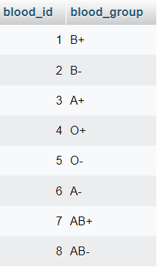

**BLOOD DONOR DETAILS:**

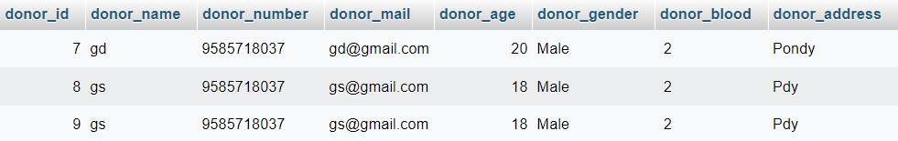

**//BLOOD_DONATION**

-- Database: `blood_donation`

-- Table structure for table `blood`

CREATE TABLE `blood` (

`blood_id` int(11) NOT NULL,

`blood_group` varchar(10) NOT NULL

) ENGINE=InnoDB DEFAULT CHARSET=latin1 COLLATE=latin1_swedish_ci;

-- Dumping data for table `blood`

INSERT INTO `blood` (`blood_id`, `blood_group`) VALUES

(1, 'B+'),

(2, 'B-'),

(3, 'A+'),

(4, 'O+'),

(5, 'O-'),

(6, 'A-'),

(7, 'AB+'),

(8, 'AB-');

-- Table structure for table `donor_details`

CREATE TABLE `donor_details` (

`donor_id` int(11) NOT NULL,

`donor_name` varchar(50) NOT NULL,

`donor_number` varchar(10) NOT NULL,

`donor_mail` varchar(50) DEFAULT NULL,

`donor_age` int(60) NOT NULL,

`donor_gender` varchar(10) NOT NULL,

`donor_blood` varchar(10) NOT NULL,

`donor_address` varchar(100) NOT NULL

) ENGINE=InnoDB DEFAULT CHARSET=latin1 COLLATE=latin1_swedish_ci;

**OUTPUT:**

1. **DONATE BLOOD:**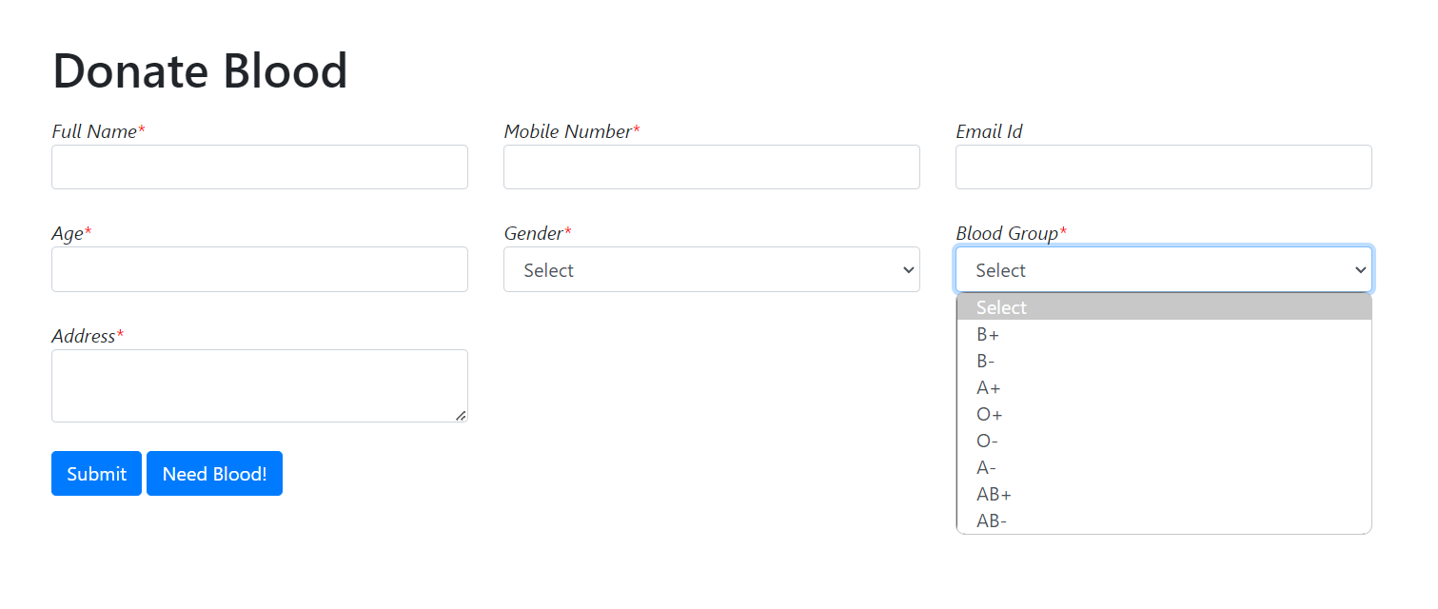
2. **NEED BLOOD:**

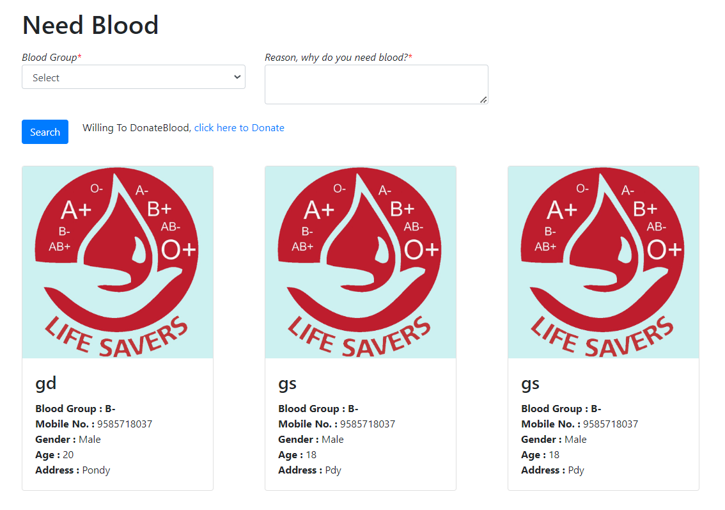

-- Dumping data for table `donor_details`

INSERT INTO `donor_details` (`donor_id`, `donor_name`, `donor_number`, `donor_mail`, `donor_age`, `donor_gender`, `donor_blood`, `donor_address`) VALUES

(7, 'gd', '9585718037', 'gd@gmail.com', 20, 'Male', ' 2', 'Pondy'),

(8, 'gs', '9585718037', 'gs@gmail.com', 18, 'Male', ' 2', 'Pdy'),

(9, 'gs', '9585718037', 'gs@gmail.com', 18, 'Male', ' 2', 'Pdy');

-- Indexes for dumped tables

-- Indexes for table `blood`

ALTER TABLE `blood`

ADD PRIMARY KEY (`blood_id`);

-- Indexes for table `donor_details`

ALTER TABLE `donor_details`

ADD PRIMARY KEY (`donor_id`);

-- AUTO_INCREMENT for dumped tables

-- AUTO_INCREMENT for table `blood`

ALTER TABLE `blood`

MODIFY `blood_id` int(11) NOT NULL AUTO_INCREMENT, AUTO_INCREMENT=9;

-- AUTO_INCREMENT for table `donor_details`

ALTER TABLE `donor_details`

MODIFY `donor_id` int(11) NOT NULL AUTO_INCREMENT, AUTO_INCREMENT=10;

COMMIT;